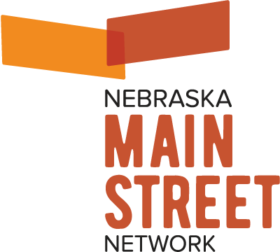

Embargoed until 8:00am Central Time on June 10, 2022

Contact: Elizabeth Chase, Executive Director, Nebraska Main Street Network
cell 402-499-3703 or director@nebraskamainstreet.org

NEBRASKA’S MAIN STREET AWARD WINNERS ANNOUNCED

Lincoln, NE (June 10, 2022) – The Nebraska Main Street Network recently announced their 2022 Inspiring Excellence Award winners, recognizing outstanding businesses, individuals, projects and activities that contribute to the economic and social vibrancy of downtown business districts in communities throughout the state.

“The hard work and steadfast dedication to downtown revitalization shown by Nebraska’s designated Main Street and Network Member communities is important for us to celebrate because it has had a huge positive impact on the state but is often overshadowed by larger projects,” said Jeff Ray, President of the Nebraska Main Street Network Board of Directors. “These communities are not only supporting small businesses, but are helping property owners re-utilize historic buildings for new uses while building strong downtown management organizations, and promoting what their districts have to offer. That’s a lot to work with!”

The Nebraska Main Street Network provides opportunities and exclusive programming to support its member communities statewide. Communities in the Network have made a commitment to revitalization and downtown management using a comprehensive economic development strategy that has been used nationwide for more than 40-years. “It’s not about a single developer coming to town to rehab a building or a city initiative being led from the top down to improve a streetscape or build a plaza. Main Street is very much a community directed, community driven approach” said Elizabeth Chase, Executive Director of the Network. “Successful downtown revitalization is not easy work nor is the success achieved overnight, so we feel very strongly as an organization that the leaders in these communities be recognized for their efforts. They are some of the most hard-working, dedicated people I know and very deserving of this pat-on-the-back.”

In addition to the community awards, the Nebraska Main Street Network recognizes Amber Holle of Falls City for
5-years of leadership directing the Falls City Chamber and Main Street, and Randy Chick, recipient of the 2022 Nebraska Main Street Network President’s Award for leading the downtown redevelopment and revitalization efforts in Hastings while selflessly sharing his knowledge and experience with countless Nebraska communities for many years.

The 2022 award recipients are:

Adaptive Reuse Project: (tie) Vintage Venue, Beatrice, NE and 40 North Tap + Grille, Grand Island, NE

New Construction Project: Beatrice Fire Hall, Beatrice, NE

Interior Improvement Residential: 210 Main Street, Wayne, NE

Interior Improvement Commercial: (tie) Clean Slate Soap, Beatrice, NE and Pinnacle Bank, Neligh, NE

Façade Improvement Project: (tie) Mercantile Building, Beatrice, NE and Neligh Family Dentistry, Neligh, NE

Public Partner Award: Big Give Gage, Beatrice, NE

Streetscape/Public Improvement Project: (4-way tie) Beatrice Murals, Beatrice, NE, Canteen District, North Platte, NE, Wayne Art Walk, Wayne, NE and Gazebo Park Restoration, Weeping Water, NE

Volunteer of the Year:
Dana Hydo, Main Street Beatrice, Beatrice, NE
Jamie Anderson, Revitalize Wayne, Wayne, NE

Business of the Year:
Quilt Stitches, Beatrice, NE
Pinnacle Bank, Neligh, NE
Tekamah Drug, Tekamah, NE
Vel’s Bakery, Wayne, NE

Honorable mentions are being awarded to Studio Sheets and The Tipsy Pig in Tekamah for their interior improvement projects. Awards will be presented throughout the summer in each award-winning community.

###

The Nebraska Main Street Network is a Main Street America™ Coordinating Program responsible for
helping Nebraska communities create vibrant and successful downtown business districts through
historic preservation, community and economic development.

ACCREDITED MAIN STREET AMERICATM COMMUNITIES INCLUDE: BEATRICE, FALLS CITY, FREMONT, GRAND ISLAND & WAYNE.

NETWORK MEMBER COMMUNITIES INCLUDE: CORTLAND, GRANT, HASTINGS, LEXINGTON, MINDEN, NELIGH,
NORTH PLATTE, PAPILLION, SCHUYLER, TEKAMAH, WEEPING WATER, AND YORK.

