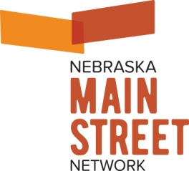 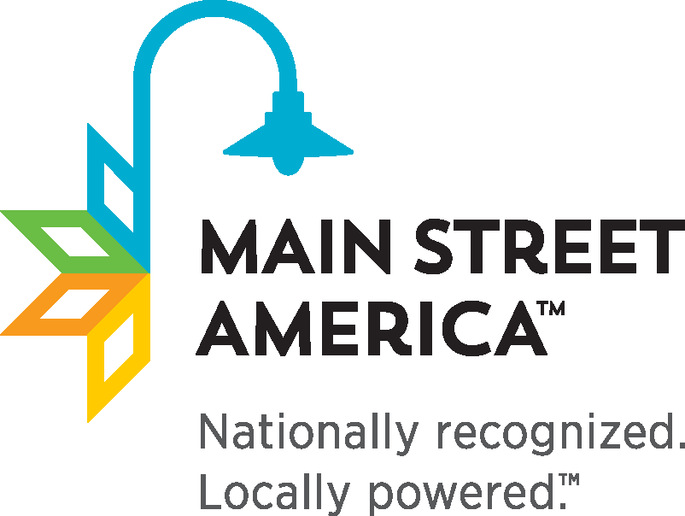

PRESS RELEASE

For Immediate Release

April 23, 2019

Contact:

Elizabeth Chase, Executive Director, Nebraska Main Street Network

phone: 402-499-3703 email: [echase@windstream.net](mailto:echase@windstream.net)

Nebraska Main Street Communities Achieve 2019 National Accreditation

Lincoln, NE (April 23, 2019) -- Beatrice, Falls City, Fremont, Grand Island, and Wayne have been designated as Accredited Main Street America™ programs for meeting rigorous performance standards set by the National Main Street Center.

Each year, the National Main Street Center and its Coordinating Program partners announce the list of accredited Main Street America programs in recognition of their exemplary commitment to preservation-based economic development and community revitalization through the Main Street Approach.

“We are thrilled to honor this year’s nationally accredited Main Street America programs for their commitment to preservation-based economic development and the revitalization of their commercial districts,” says Patrice Frey, President & CEO of the National Main Street Center. “The power of Main Street shines across the country through these vibrant communities, who have all worked to generate impressive economic returns, preserve community character, and celebrate local history. In 2018 alone, Main Street America programs generated $4.93 billion in local reinvestment, helped open 5,310 net new businesses, generated 25,301 net new jobs, catalyzed the rehabilitation of 8,146historic buildings, and clocked 2.2 million volunteer hours."

Each community's performance is annually evaluated by the Nebraska Main Street Network, which works in partnership with the National Main Street Center to identify the local programs that meet ten national performance standards. Evaluation criteria determines the communities that are building comprehensive and sustainable revitalization efforts and include standards such as fostering strong public-private partnerships, documenting programmatic progress, and actively preserving historic buildings.

Main Street America has been helping revitalize older and historic commercial districts for almost 40 years. Today, it is a network of more than 1,600 neighborhoods and communities, rural and urban, who share both a commitment to place and to building stronger communities through preservation-based economic development. Since 1980, communities participating in the program have leveraged more than $79.12 billion in new public and private investment, generated 640,017 net new jobs and 143,613 net new businesses, and rehabilitated more than 284,936 buildings. Main Street America is a program of the nonprofit National Main Street Center, a subsidiary of the National Trust for Historic Preservation.

# # #

[www.nebraskamainstreet.org](http://www.nebraskamainstreet.org)